PROJECT TITLE
Visualizing Housing Market Trends Using Tableau: An Interactive Data Analytics Dashboard for Property Price Analysis

2. PROJECT DESCRIPTION

2.1 System Overview
The Housing Market Trends Visualization project is a data analytics system designed to analyze housing market data and transform raw property datasets into meaningful visual insights using interactive dashboards created in Tableau.
Housing markets generate a large amount of data related to property characteristics, property prices, and market behavior. Analyzing such data using traditional methods can be time-consuming and inefficient. Data visualization tools allow analysts to interpret complex datasets more effectively.
This project demonstrates how modern data visualization techniques can be used to explore housing datasets and identify patterns in property pricing. The dataset used in this project includes multiple attributes such as property price, number of bedrooms, area size, and other structural details that influence property valuation.
Using Tableau, the project creates interactive visualizations such as bar charts, scatter plots, and dashboards that allow users to explore relationships between different housing attributes. These visualizations help users understand how factors like property size, number of rooms, and property features affect housing prices.
The system enables users to interact with visual dashboards using filters and parameters. This allows analysts to dynamically explore data and generate insights about housing trends.

2.2 Problem Domain
The real estate market is influenced by multiple factors including property size, location, number of bedrooms, property condition, and surrounding infrastructure. Real estate companies and investors rely on data analysis to make informed decisions regarding property investments.
However, analyzing housing market data manually is difficult because datasets often contain thousands of records and multiple attributes. Without visualization tools, identifying meaningful patterns in such datasets becomes challenging.
The main problem addressed by this project is the lack of intuitive tools for analyzing housing market datasets. The system solves this problem by converting raw housing data into interactive visual dashboards that allow users to easily understand market patterns and relationships between housing attributes.
By using Tableau dashboards, users can quickly identify trends in housing prices and evaluate how different property features influence market value.

2.3 Core Technology Used

Tableau
Tableau is the primary data visualization tool used in this project. It provides a powerful environment for connecting to datasets, transforming data, and creating interactive visualizations.
Tableau allows users to build dashboards using drag-and-drop features, enabling the creation of complex visual analytics without extensive programming knowledge.
Key Tableau features used in the project include:
- Data connections
- Calculated fields
- Interactive filters
- Dashboard creation
- Data aggregation
- Data blending

Data Analytics Techniques
Several data analytics techniques are applied in this project including:
Data Cleaning
The dataset is checked for missing values, inconsistent records, and formatting issues. Data cleaning ensures that the dataset is accurate and suitable for analysis.
Data Transformation
Data transformation techniques are used to convert raw data into a structured format suitable for visualization.
Exploratory Data Analysis
Exploratory analysis is performed to understand the relationships between different housing attributes.
Trend Identification
Visualization techniques are used to identify trends in housing prices across different property characteristics.

Dataset
The dataset used in this project contains structured housing data including several attributes related to residential properties. These attributes represent important factors that influence property prices.
Examples of attributes include:
- Property price
- Number of bedrooms
- Property area
- Structural characteristics
The dataset serves as the foundation for the entire analytics process.

2.4 Key Capabilities
The system provides multiple capabilities that help users analyze housing market data effectively.

Data Exploration
Users can explore the dataset using interactive dashboards and visual charts.

Market Trend Identification
The system identifies trends in housing prices and property demand.

Feature Comparison
Users can compare different housing attributes such as room count, property size, and price.

Visual Pattern Analysis
Visualization techniques make it easier to identify patterns within the dataset.

Interactive Reporting
Dashboards allow users to generate visual reports that summarize housing market insights.

2.5 Target Users
The project is designed for several categories of users who benefit from housing market analysis.

Real Estate Analysts
Professionals working in the real estate sector can use the system to analyze property trends and evaluate investment opportunities.

Property Investors
Investors can use the dashboard to identify profitable housing investments based on property characteristics and price trends.

Data Analysts
Data analysts can use the project as an example of how visualization tools can be used to analyze complex datasets.

Academic Researchers
Researchers studying real estate markets can use the system to examine property pricing trends.

Students
Students learning data analytics and visualization can use the project to understand real-world applications of analytics tools.

2.6 Real-world Relevance
The housing market is an important component of the global economy. Understanding housing trends helps stakeholders make informed decisions regarding property investments and urban development.
Data visualization plays an important role in modern real estate analytics by enabling professionals to analyze large datasets efficiently.
This project demonstrates how data visualization tools like Tableau can be used to simplify complex datasets and generate valuable insights that support real-world decision making.

3. APPLICATION SCENARIOS / USE CASES

Enterprise Usage
Real estate companies and property developers can use housing analytics dashboards to evaluate market trends and identify profitable investment opportunities.
For example, by analyzing property price distributions across different property sizes, organizations can determine which types of properties are most in demand.

End-user Usage
Individual home buyers can use housing market dashboards to compare properties based on attributes such as price, area, and number of bedrooms. This allows buyers to evaluate whether a property is priced fairly relative to other properties in the market.

Educational Usage
Educational institutions can use the project as a case study for teaching data analytics and visualization techniques. Students can learn how raw datasets can be transformed into meaningful visual insights.

Industrial Usage
Urban planners and government agencies can analyze housing market data to understand housing demand patterns and develop infrastructure planning strategies.

4. TECHNICAL ARCHITECTURE OVERVIEW

4.1 High-Level Architecture Diagram
Housing Dataset
↓
Data Cleaning & Preprocessing
↓
Tableau Data Model
↓
Visualization Engine
↓
Interactive Dashboards
↓
User Interaction
↓
Insights & Analysis

4.2 Component Interaction Diagram
The system consists of several components that work together to process housing data and generate insights.
Dataset Source → Data Processing → Visualization Engine → Dashboard Layer → User Interface
Each component performs a specific function in the data analytics pipeline.

4.3 Data / Request Flow
The data flow within the system follows these steps:
- Housing dataset is collected and stored in CSV format.
- The dataset is imported into Tableau.
- Data cleaning and preprocessing operations are performed.
- Visual charts are created to represent different housing attributes.
- Multiple visualizations are combined into dashboards.
- Users interact with dashboards to analyze housing market trends.

4.4 System Layers

Frontend Layer
The frontend layer consists of interactive Tableau dashboards that allow users to explore housing data visually.

Backend Layer
The backend layer consists of Tableau's data processing engine that performs data aggregation and query execution.

Database Layer
The database layer consists of structured datasets stored in CSV or Excel format.

External APIs / Services
Although the project currently uses static datasets, external APIs can be integrated in future versions to provide real-time housing data.
Possible APIs include:
- Real estate listing APIs
- Government housing data APIs
- Property valuation APIs
These APIs could enable dynamic updates of housing market data.

Deployment Environment
The project is developed using Tableau Desktop and can be deployed using Tableau Public.

5. PREREQUISITES

Software Requirements
The following software tools are required for project development:
- Tableau Desktop
- Microsoft Excel
- GitHub
- Web browser
- Operating system (Windows or MacOS)

Libraries / Frameworks / Dependencies
The project primarily uses built-in Tableau features and does not require additional programming libraries.
Dependencies include:
- Tableau visualization engine
- Dataset files
- Dashboard components

Hardware Requirements
The system requires a standard computing environment including:
- Minimum 4GB RAM
- Dual-core processor
- 1GB free storage
- Internet connectivity

6. PRIOR KNOWLEDGE REQUIRED
Users working with this project should understand:
- Data analytics concepts
- Tableau fundamentals
- Data visualization principles
- Basic statistics
- Structured datasets

7. PROJECT OBJECTIVES
Technical objectives include:
- Importing housing datasets
- Performing data preprocessing
- Creating meaningful visualizations
- Building interactive dashboards
Performance objectives include:
- Fast dashboard loading
- Accurate data representation
Deployment objectives include:
- Publishing dashboards online
Learning outcomes include gaining practical experience in data analytics workflows.

8. SYSTEM WORKFLOW
The system workflow explains the step-by-step process followed in the project to transform raw housing data into meaningful insights using Tableau visualization tools.

Step 1: Data Collection
The housing dataset is collected from an open data source such as Kaggle or a real estate dataset repository. The dataset typically contains information such as property price, number of bedrooms, square footage, location, year built, and other housing features.

Step 2: Data Cleaning and Preprocessing
Before visualization, the dataset is cleaned to remove errors and inconsistencies. This includes:
- Handling missing values
- Removing duplicate records
- Converting data types
- Standardizing column names
- Removing outliers that may distort analysis
Tools such as Excel or Python libraries (Pandas) may be used for preprocessing.

Step 3: Data Import into Tableau
After cleaning, the dataset is imported into Tableau using:
- CSV file connection
- Excel file connection
- Or through a Data API connection (if the dataset is obtained dynamically from a data source).
Tableau reads the dataset and automatically detects data fields and data types.

Step 4: Data Processing
Tableau processes the dataset internally using its analytics engine. During this phase:
- Dimensions and measures are identified
- Aggregations such as SUM, AVG, COUNT are applied
- Calculated fields may be created for advanced analysis.

Step 5: Visualization Creation
Different charts and visualizations are created, such as:
- Bar charts
- Line charts
- Scatter plots
- Heat maps
- Price distribution graphs
These charts help users understand relationships between housing features and prices.

Step 6: Dashboard Development
Multiple visualizations are combined into interactive dashboards. Dashboards allow users to:
- Compare data
- Apply filters
- Explore trends interactively.

Step 7: Insight Generation
The final step involves interpreting the visualizations to identify:
- Price trends
- High-value locations
- Feature impact on property prices.

9. MILESTONE 1 – REQUIREMENT ANALYSIS

Problem Definition
The housing market generates large volumes of data related to property prices, features, and locations. Analyzing this data manually is difficult and time-consuming. Therefore, a visualization system is required to transform raw housing data into meaningful visual insights that help users understand market trends.

Functional Requirements
Functional requirements describe what the system must do.
- Dataset Import
  - The system should allow users to load housing datasets from CSV or Excel files.
- Data Visualization
  - The system must generate charts and graphs representing housing market trends.
- Interactive Dashboard
  - Users should be able to interact with dashboards by applying filters and selecting variables.
- Data Filtering
  - The system should allow filtering based on:
  - price range
  - location
  - number of bedrooms
  - property size
- Insight Generation
  - The system should provide visual insights that help users understand price variations.

Non-Functional Requirements
These describe the quality and performance of the system.
- Performance
  - The dashboard should load quickly even with large datasets.
- Usability
  - The system should be easy to understand for non-technical users.
- Scalability
  - The system should support additional datasets in the future.
- Reliability
  - The visualizations should display accurate information without errors.

10. MILESTONE 2 – ENVIRONMENT SETUP

Step 1: Install Tableau Desktop
Download and install Tableau Desktop from the official Tableau website. Tableau Desktop is the main software used to create visualizations and dashboards.

Step 2: Download Housing Dataset
The housing dataset is downloaded from an open dataset repository such as Kaggle. The dataset contains housing attributes including price, location, square footage, and other property characteristics.

Step 3: Load Dataset into Tableau
Open Tableau Desktop and connect to the dataset by selecting:
- Connect → To a File → Excel / CSV
Once the file is selected, Tableau automatically loads the dataset.

Step 4: Configure Data Fields
After loading the dataset:
- Dimensions and measures are verified.
- Incorrect data types are corrected.
- Calculated fields may be created if necessary.
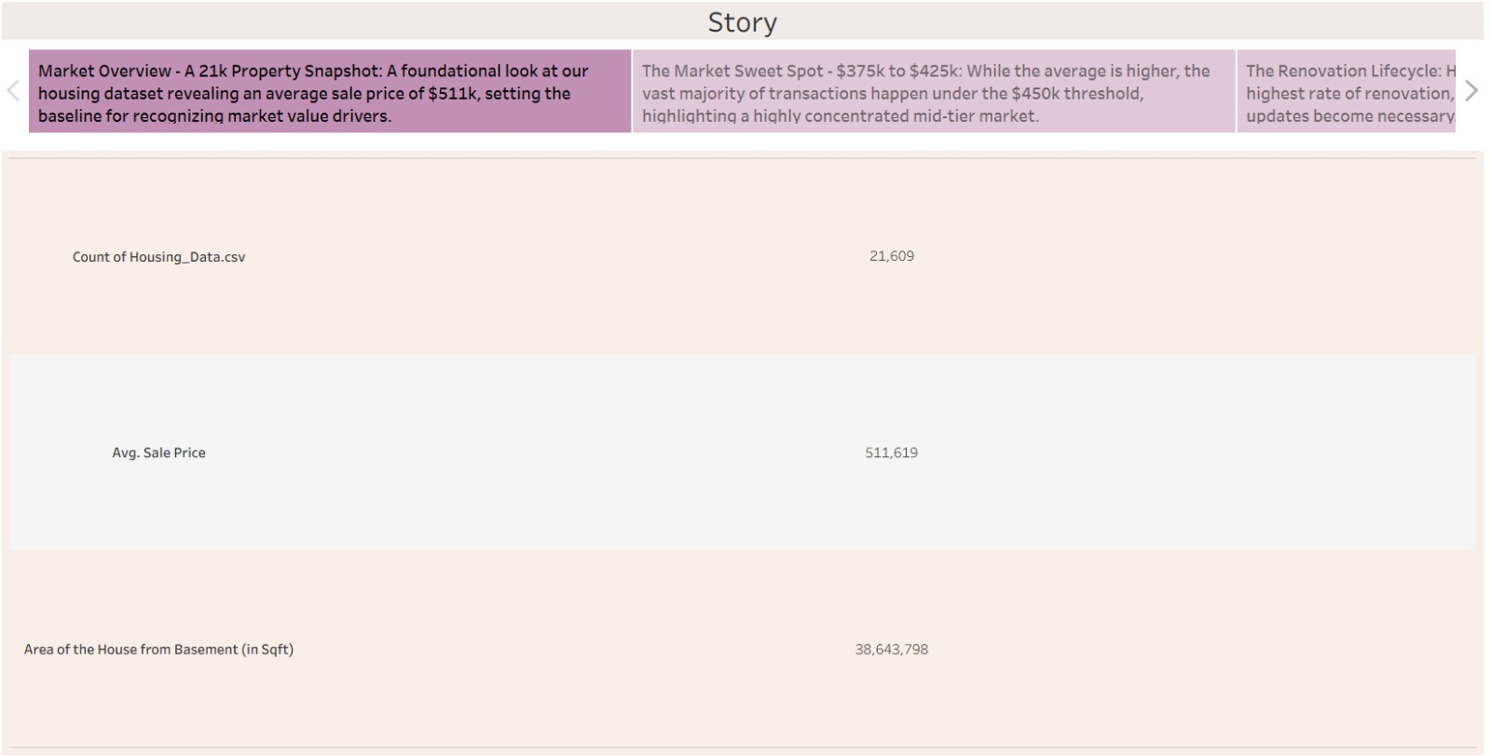

11. MILESTONE 3 – CORE SYSTEM DEVELOPMENT

Feature 1 – Data Visualization
The primary functionality of the project is creating visual representations of housing market data.
Examples include:
Price Trend Analysis
Line charts show how housing prices change over time.
Feature Impact Visualization
Scatter plots show how variables like square footage or number of bedrooms affect price.
Location-based Comparison
Maps or bar charts compare property prices across locations.
These visualizations help identify patterns and correlations.

Feature 2 – Dashboard Creation
Dashboards integrate multiple visualizations into a single interface.
Key dashboard components include:
- Price trend charts
- Feature comparison graphs
- Geographic price distribution
- Filter controls
The dashboard allows users to interact with the visualizations dynamically.

Feature 3 – Data Filtering
Interactive filters enable users to customize the analysis.
Examples of filters include:
- Price range
- Property type
- Location
- Number of bedrooms
- Year built
When a filter is applied, Tableau automatically updates all visualizations in the dashboard.

12. MILESTONE 4 – INTEGRATION & OPTIMIZATION
In this phase, all developed visualizations are integrated into a unified dashboard system.
Key optimization tasks include:
- Reducing unnecessary calculations
- Optimizing dataset size
- Improving dashboard layout
- Enhancing responsiveness
These optimizations ensure that the dashboard performs efficiently and provides smooth user interaction.

13. TESTING & VALIDATION
Testing ensures that the system functions correctly and produces accurate visualizations.

Test Case 1 – Dataset Loading
Input: Load housing dataset
Expected Result: Dataset appears correctly in Tableau data pane.

Test Case 2 – Filter Application
Input: Apply price range filter
Expected Result: Dashboard visualizations update automatically.

Test Case 3 – Dashboard Rendering
Input: Open dashboard
Expected Result: All charts load correctly without errors.
https://housing-market-trends.vercel.app/dashboard

14. DEPLOYMENT
Deployment involves publishing the Tableau dashboard so that users can access it.

Deployment Steps
- Finalize the dashboard in Tableau Desktop.
- Publish the dashboard to Tableau Public or Tableau Server.
- Generate a shareable dashboard link.
- Share the visualization with users through web access.
Users can interact with the dashboard directly through a web browser.

15. PROJECT STRUCTURE
The project follows a structured folder organization.
project_root/
│
├ dataset/
│ housing_data.csv
│
├ dashboards/
│ housing_dashboard.twb
│
├ visualizations/
│ price_trend_chart
│ location_comparison_chart
│
├ documentation/
│ project_report.docx
│
└ README.md
This structure helps maintain project files in an organized manner.

16. RESULTS
The project successfully developed an interactive Tableau dashboard that visualizes housing market trends.
Key results include:
- Clear visualization of housing price patterns
- Ability to compare property features
- Interactive filtering for deeper analysis
- Improved understanding of housing market behavior
The dashboard allows users to explore housing data easily and identify meaningful insights.
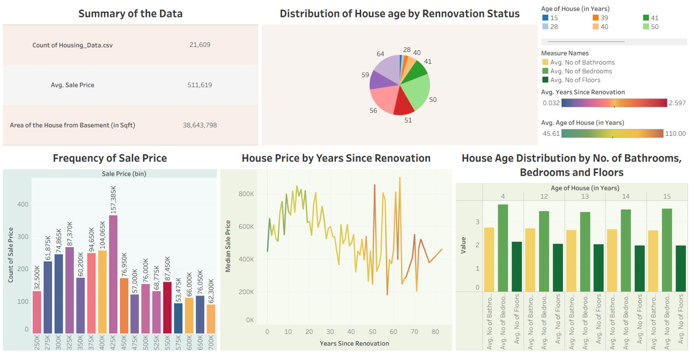

17. ADVANTAGES & LIMITATIONS

Advantages
- Simplifies complex housing data through visual representation.
- Interactive dashboards allow dynamic exploration of data.
- Supports quick decision-making.
- Easy to share and access online.

Limitations
- Results depend on dataset quality.
- The system does not include predictive analytics.
- Real-time data updates are not implemented.

18. FUTURE ENHANCEMENTS
The project can be improved in several ways.
- Real-Time Data Integration
  - Integrate real estate APIs to fetch live housing market data.
- Machine Learning Price Prediction
  - Use machine learning models to predict housing prices.
- Mobile Dashboard Support
  - Optimize dashboards for mobile devices.
- API Integration
  - Connect external real estate APIs to automatically update datasets.
Example APIs that could be integrated:
- Real estate listing APIs
- Location and map APIs
- Market analytics APIs

19. CONCLUSION
This project demonstrates the power of data visualization in understanding complex housing market data. Using Tableau, raw housing datasets were transformed into interactive dashboards that reveal important trends and relationships.
The project highlights how data analytics and visualization tools can support decision-making in the real estate industry. With further enhancements such as API integration and predictive analytics, the system can evolve into a more advanced housing market intelligence platform.
I checked the document you uploaded. Your GitHub repository link is already given as:
https://github.com/milind2k4/Housing-Market-Trends
So the Appendix should reference that repository and describe its contents, instead of writing generic text. Use something like this:

20. APPENDIX

A. Source Code
The implementation of the project is stored in the GitHub repository. The source files include the Tableau workbook used to build the visualizations and dashboards.
The Tableau workbook contains:
- Data visualization worksheets
- Interactive dashboard components
- Filters and calculated fields
- Data connections to the housing dataset
These files collectively implement the housing market analysis system.
The source code and project files can be accessed at:
GitHub Repository:
https://github.com/milind2k4/Housing-Market-Trends

B. Configuration Files
The project configuration consists of Tableau data connections and dashboard settings.
Key configuration components include:
- Dataset Connection
  - Housing dataset connected to Tableau through CSV/Excel file.
- Visualization Configuration
  - Chart formatting
  - Axis settings
  - Labels and legends
- Dashboard Layout Configuration
  - Arrangement of visualizations
  - Interactive filters
  - Dashboard formatting.
These configurations ensure that the data is correctly processed and visualized.

C. Dataset Details
The dataset used in this project contains housing market information such as property prices and house features.
Dataset Name: Housing Market Dataset
Format: CSV / Excel

Key Dataset Attributes
Attribute | Description
Price | Selling price of the house
Bedrooms | Number of bedrooms
Bathrooms | Number of bathrooms
Sqft_Living | Size of the house in square feet
Floors | Number of floors
Condition | Overall condition rating
Grade | Construction quality
Year Built | Year the house was built
Location | Area or region of the property
This dataset is used to analyze patterns in housing prices and generate visual insights using Tableau.

D. API Documentation
An Application Programming Interface (API) allows different applications to communicate with each other and exchange data.
Although the current version of this project uses a static dataset, APIs could be integrated in the future to obtain real-time housing market data.
Possible APIs include:
- Real estate listing APIs
- Geographic location APIs
- Housing market analytics APIs
API requests typically use HTTP methods such as:
- GET – Retrieve data
- POST – Send data
- PUT – Update existing data
- DELETE – Remove data
Most APIs return responses in JSON format, which can be processed by applications and visualization tools.

E. GitHub Repository Link
The complete project including documentation, dataset references, and visualization files is available in the GitHub repository.
Repository Link:
https://github.com/milind2k4/Housing-Market-Trends
.

